Giordano Iacoviello, 000842113

**Lab 01 Reflection**

**2.** All requestedfeatures in this lab are working.

3. Through this lab, I learned:

1. More easily create a project with Identity from scratch

2. Error fixing for unexpected exceptions/issues

3. General controller authentication rules

4. Three things I should continue to practice:

1. Double checking code instead of running into exceptions on every run

2. Aside from this, the lab was fairly easy and smooth.

5.

**MANAGER GET:**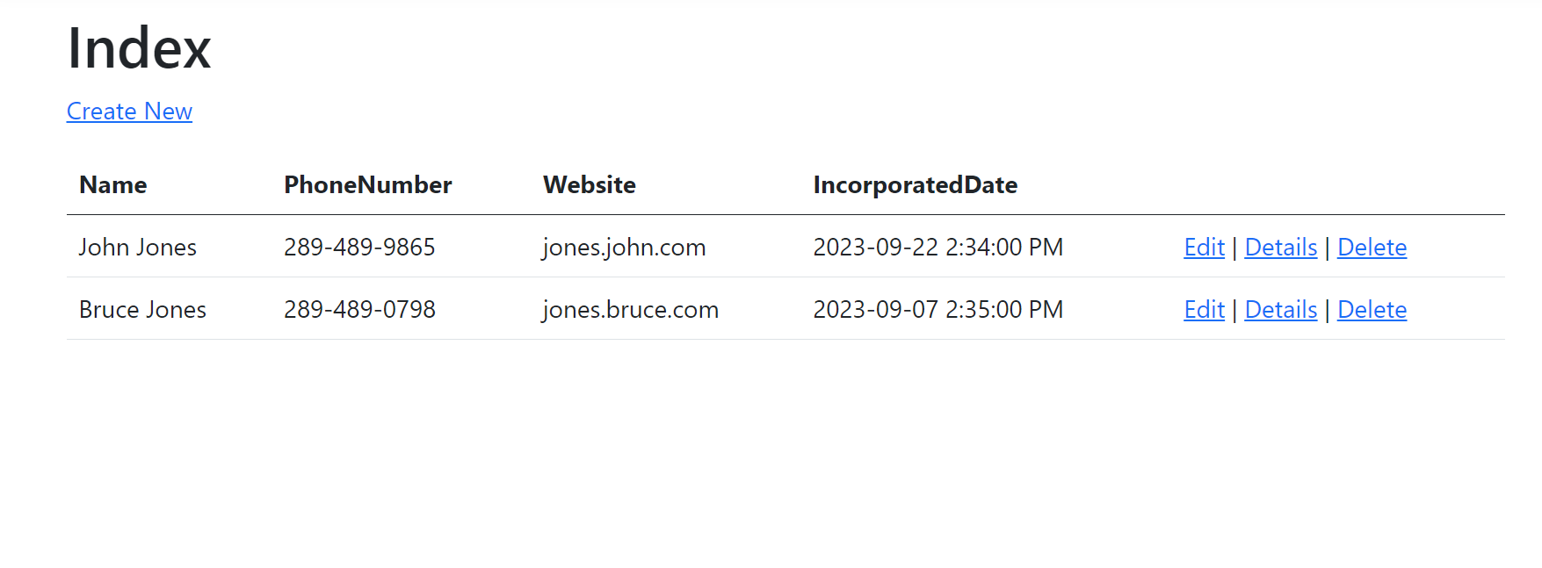

**MANAGER CREATE:**

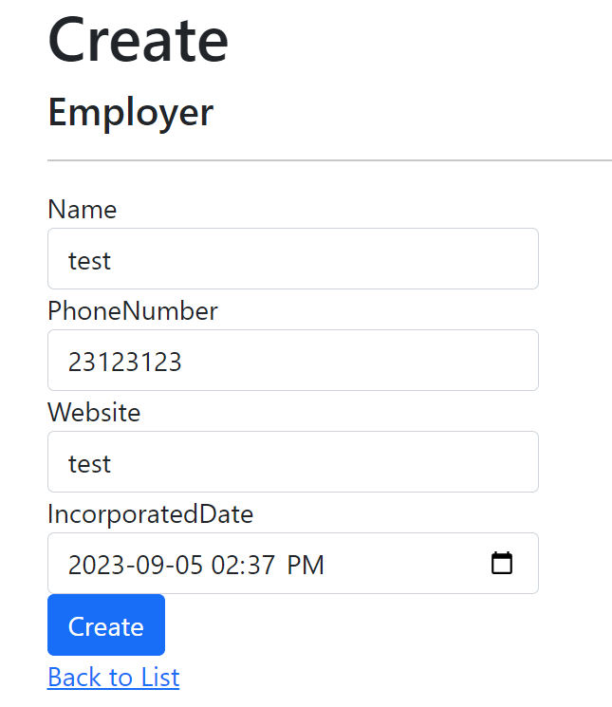

**EMPLOYEE GET:**

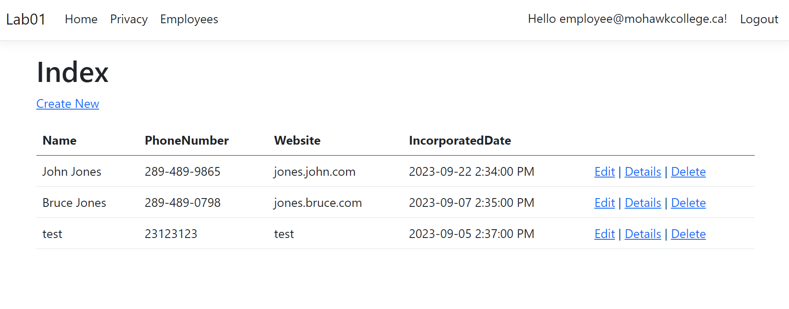

**EMPLOYEE CREATE:**

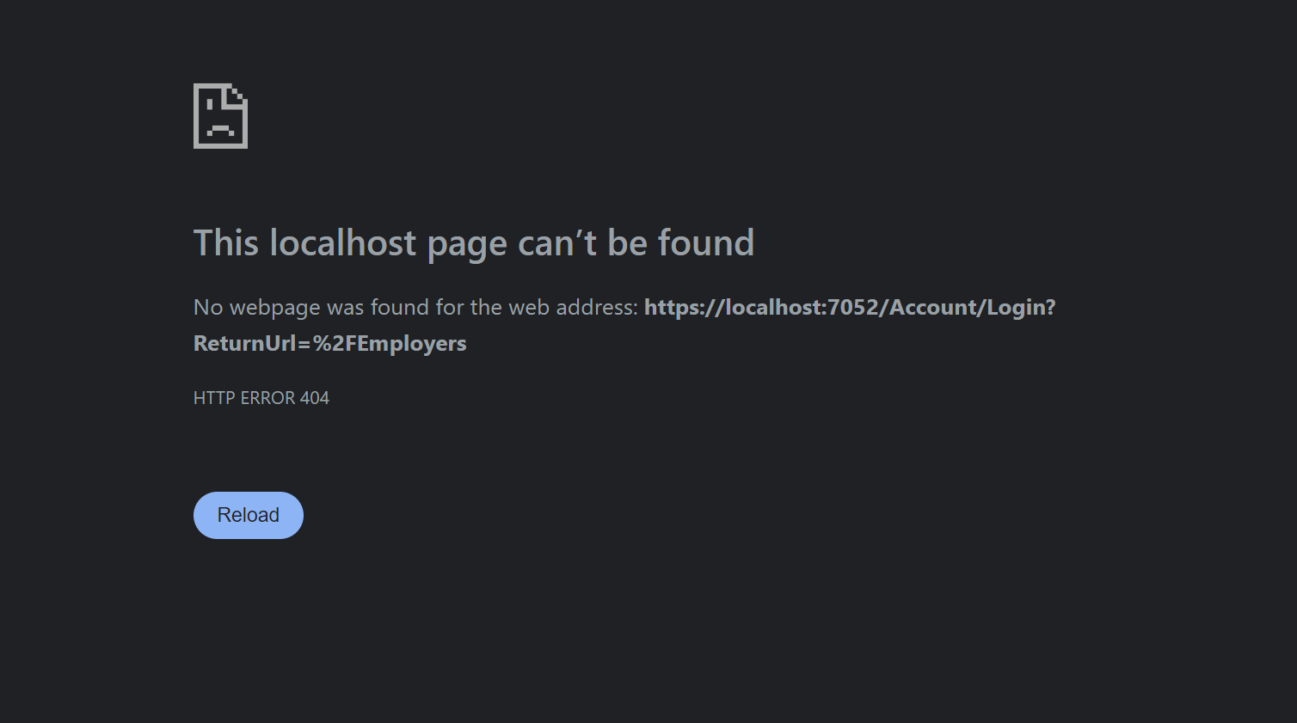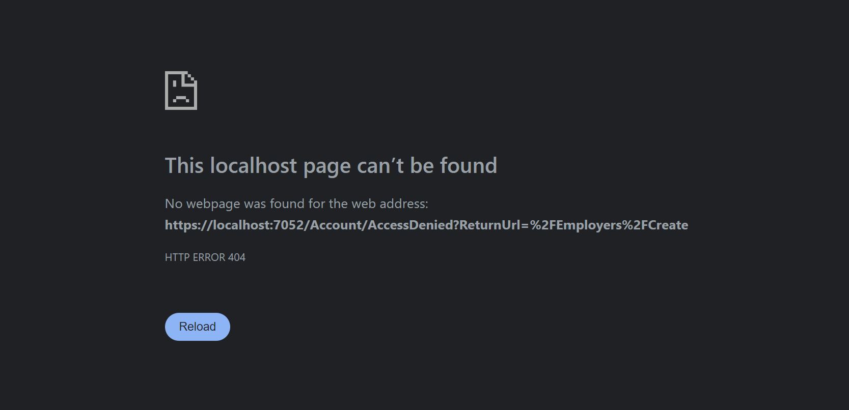

**UNAUTHORIZED USER GET:**